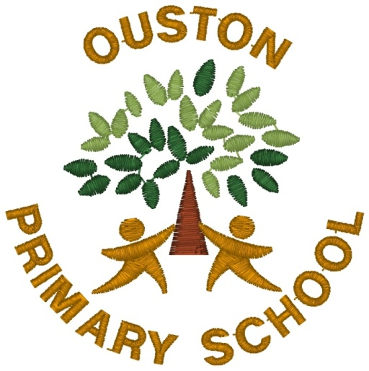

Ouston Primary School – Class Novel Spine – Years 1 – 6
Cycle A
KS1 Topic | Year 1 | Year 2 | LKS2 Topic | Year 3 | Year 4 | UKS2 Topic | Year 5 | Year 6
Food | Handa’s Surprise  The Magic  Porridge Pot | Rigatoni the Pasta Cat  Soul Food Sunday | Romans | Julius Zebra: Rumble with the Romans | Thieves of Ostia | Mountains and Volcanoes | The Abominables | Night of the Howling Dogs
St. Lucia | Gregory Cool  Sofia the Dreamer and her Magical Afro | Tales from the Caribbean (Choose tales that best compliment writing KPIs) | Earthquakes | I Survived the San Francisco Earthquake | Earthquake Terror | Evolution and Inheritance | Darwin’s Dragons | Skellig
Great Fire of London | Toby and the Great Fire of London  The Gingerbread Man | The Baker’s Boy and the Great Fire of London | Sustainability | Song of the Dolphin Boy | The Extraordinary Colours of Auden Dare | Shang | The Firework Maker’s Daughter | The Kite Rider
Seaside | The Lighthouse Keeper’s Lunch  Various non-fiction examples | Dolphin Boy | Stone Age | The Wild Way Home | Wolf Brother | Earth and Space | The Jamie Drake Equation | Cosmic
Vesuvius/Pompeii | tbc | tbc | Bronze/Iron Age | Boy with the Bronze Axe | The Warrior Scarlet | Maya | The Curse of the Maya | Oh Maya Gods!
Victorians | Queen Victoria’s Bathing Machine  Daisy Saves the Day | The Secret Diary of Jane Pinny | World Climates | Rumblestar | The Weather Weaver | Fair Trade | Stormbreaker (non-linked) | Silverfin  (non-linked)

Cycle B
KS1 Topic | Year 1 | Year 2 | LKS2 Topic | Year 3 | Year 4 | UKS2 Topic | Year 5 | Year 6
Local Area | Three Little Wolves and The Big Bad Pig  The Building Boy | George’s Marvellous Medicine | Ancient Egypt | Ma’at’s Feather | Secrets of the Sun King | Rivers and Erosion | Wind in the Willows | Holes
Kampong Ayer | Mama Panya’s Pancakes  Mama Miti | Flat Stanley | Florida | The Last Egret | Because of Winn-Dixie | British Empire | Coming to England | Windrush Child
History Makers/ Superheroes | Supertato  Traction Man is Here | Super Dad’s Day Off | Anglo-Saxons | Beowulf (Morpurgo) | Anglo-Saxon Boy | Climate Change | Floodland | The Last Wild
Explorers/ Pirates | How I Became a Pirate  The Pirate Cruncher | The Jolley Rogers and the Cave of Doom | Megacities | Royal Rabbits of London | London Eye Mystery | Trojan Horse | Mark of the Cyclops | Who Let the Gods Out?
Antarctica | The Rainbow Bear  The Emperor’s Egg | Pugs of the Frozen North | Vikings | How to Train your Dragon | Riddle of the Runes | Battle of Britain (WW2) | The Silver Sword | Once
Transport | Mrs Armitage on Wheels  Mrs Armitage: Queen of the Road | Kaspar: Prince of Cats | India/Tigers | The Tiger Rising | When the Mountains Roared | Local Area | The Boy at the Back of the Class  (non-linked) | Crater Lake  (non-linked)

