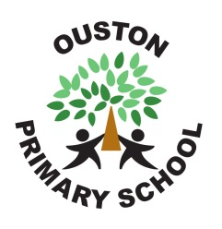
Modern Foreign Languages Policy

Curriculum Statement
Ouston Primary School believes that the learning of a foreign language provides a valuable educational, social and cultural experience for the pupils. Pupils develop communication and literacy skills that lay the foundation for future language learning. They develop linguistic competence, extend their knowledge of how language works and explore differences and similarities between the foreign language and English. Learning another language raises awareness of the multi-lingual and multi-cultural world and introduces an international dimension to pupils’ learning, giving them an insight into their own culture and those of others. The learning of a foreign language provides a medium for cross-curricular links and for reinforcement of knowledge, skills and understanding developed in other subjects.

“Learning a foreign language is a liberation from insularity and provides an opening to other cultures. A high-quality languages education should foster pupils’ curiosity and deepen their understanding of the world. The teaching should enable pupils to express their ideas and thoughts in another language and to understand and respond to its speakers, both in speech and in writing. It should also provide opportunities for them to communicate for practical purposes, learn new ways of thinking and read great literature in the original language. Language teaching should provide the foundation for learning further languages, equipping pupils to study and work in other countries.” National Curriculum in England (DfES September 2013)

Intent
The Department for Education (DfE) published statutory guidance on the National Curriculum in England for Key Stage (KS) 1 to KS4. It states that languages are not a compulsory subject in schools at KS1. The National Curriculum document states that foreign languages are a compulsory subject at KS2.
Teaching may be of any modern or ancient foreign language and should "lay the foundations" for foreign language learning at KS3.
The 2013 National Curriculum for Modern Foreign Languages aims to ensure that all children:
• Understand and respond to spoken and written language from a variety of authentic sources.
• Are able to speak with increasing confidence, fluency and spontaneity, finding ways of communicating what they want to say, including through discussion and asking questions, and that they are continually improving the accuracy of their pronunciation and intonation.
• Can write at varying length, for different purposes and audiences, using the variety of grammatical structures that they have learnt.
• Discover and develop an appreciation of a range of writing in the language studied.
At Ouston Primary School we teach French, based on popularity of choice at KS3, staff knowledge and availability of quality resources..Our main objectives in the teaching of French are to promote the development of linguistic competence and confidence in speaking and writing as well as an understanding and awareness of the world and other cultures.

Implementation
Children in Year 2 are given the opportunity to attend a French After School Club. This acts as an introduction to basic language skills, with activities including songs, rhymes and games.
In KS2, each class has a timetabled French lesson of 45 minutes. Lessons across the Key Stage support the skills of speaking, listening, reading and writing:
• Children are taught to listen attentively to spoken language and respond, joining in with songs, rhymes and games.
• Children develop an appreciation of a variety of stories, songs, poems and rhymes in French. that are delivered through the curriculum content.
• We follow the planning and guidance of the Durham PMFL team using the QCA Scheme of work and the Durham resources. These are available online as well as in school.

Impact

Our MFL curriculum ensures that children develop their knowledge of where different languages are spoken in the world. Varied learning experiences, including ‘One Britain Week’ and ‘International Day of Languages ’ also ensure that languages are celebrated throughout the school community whilst providing a context for language learning and develop the children’s understanding of different cultures. Our School was recently awarded the Foundation level of the ‘ International School Award’ by the British Council, which celebrates our international work, in particular our link with Nord Anglia International School, Hong Kong.

Teaching and Learning
KS1
Although not statutory at this stage, pupils in KS1 are introduced to other languages. Greetings, registers, classroom routines and praise words are regularly conducted in another language.

KS2
We use a variety of techniques to encourage the children to have an active engagement in the modern foreign language: these include games, role-play and action songs. We use puppets and soft toys to demonstrate the foreign language, and, where possible, we also invite native speakers into the classroom to provide an excellent model of the spoken language as well as to involve the children in learning about the culture of country. We use mime to accompany new vocabulary as this serves to demonstrate the language without the need for translation. We emphasise listening, responding and speaking skills in Years 3 and 4 with the addition of simple reading and writing skills as the pupils progress through Years 5 and 6.

We use a multi-sensory and kinaesthetic approach to teaching i.e. we try to introduce a physical element into some of the games, rhymes and songs as we believe this serves to reinforce memory. We make lessons as enjoyable as possible so that the children develop a positive attitude to the learning of modern foreign languages. We build the children’s confidence through praise for any contribution they make however tentative.

Organisation, Planning and Resources
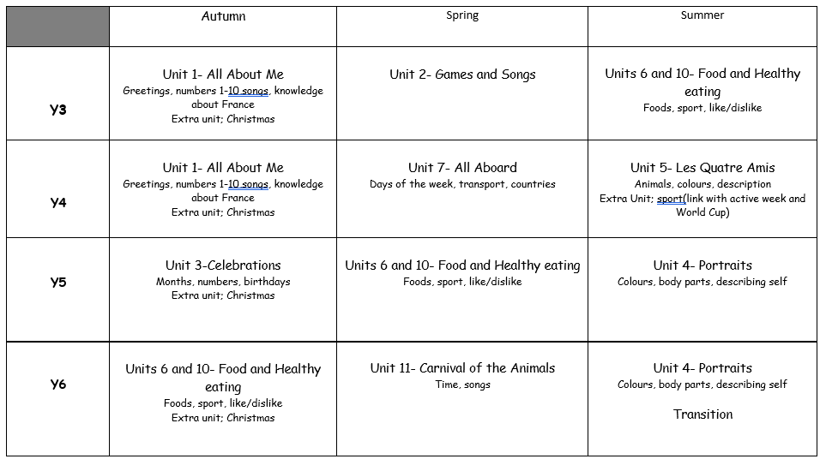

Assessment

The children are assessed continually throughout the year, with the teacher giving feedback orally, through marking and verbally. This process is supported by the end of KS2 statements in the National Curriculum 2014. Children regularly review their work against ‘I can…’ statements for their year group, which mark the beginning of the outcomes of work for that year, in the child’s French booklets.

Equal Opportunities
At Ouston Primary we are committed to promoting equal opportunities irrespective of socioeconomic background, gender, disability and ethnicity in all areas of the curriculum. We believe all children should have access to and participation in the learning of languages and to be supported in this process.

Inclusion
At Ouston Primary we teach a modern foreign language to all children, whatever their ability. A modern foreign language forms part of the school’s commitment to providing a broad and balanced education to all children. Through our modern foreign language teaching, we provide learning opportunities that enable all children to make progress. We do this by setting suitable learning challenges and responding to each child's different needs.

Role of the Subject Leader
The subject leader is responsible for the coordination and planning of the MFL curriculum. The subject leader also;
- supports colleagues in their teaching, by keeping them informed about current developments in MFL
- Writes a subject development plan, informed by the whole school development plan
- attends specialist courses and ensures content is disseminated to staff
- informs governors about current teaching of MFL in school

Working with Parents/Carers
Parents and carers have an important role to play in helping their children to learn about languages. They can encourage their child to practise the language we learn every week and help to understand the differences in culture.

Policy Review Date:
June 2024

