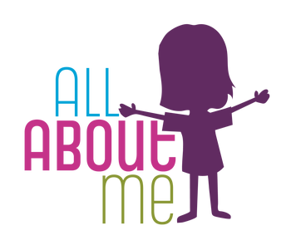
Autumn 1 ~ ‘All About Me’

Focus areas of Development and Learning for this topic;
~ Personal, Social and Emotional Development
~ Communication and Language
~ Physical Development

Our first theme is ‘All About Me’. This involves getting to know the children really well and allowing them opportunities to get to know each other through play interactions. We learn our class rules and systems. There is also a big focus on developing children’s independence and confidence in accessing resources and making relationships with their peers and staff.
We use mirrors to look closely at our facial features and paint self-portraits.

PE
The children will start PE after the first few weeks when they are more settled. The initial focus is on listening to instructions and exploring different ways of moving.
Children will spend lots of time in our outdoor area and have opportunities to run, skip, jump and access small bikes and scooters. They learn how to negotiate the space around them safely.

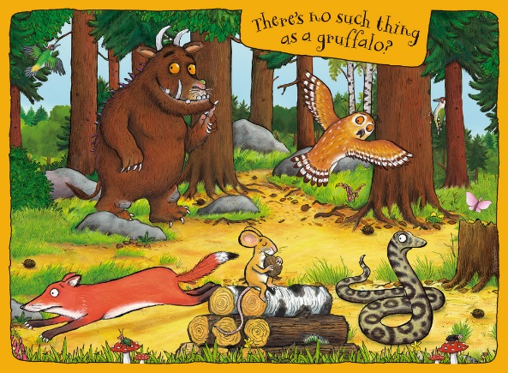
Autumn 2 - ‘Into The Woods’

Focus areas of Development and Learning for this topic;
~ The Natural World (Science)
~ People, Culture & Communities (Geography)
~ Expressive Arts and Design

The theme this half-term is ‘Into the Woods’. We use our focus books; ‘The Gruffalo’ and ‘Owl Babies’, to allow us to explore the physical features of forests and woodlands and the animals that live there. This includes learning about nocturnal animals. We also discuss the issue of litter and how recycling is a way we can help to look after our world.
We learn about Diwali and Christmas, and the children begin to understand the importance of respecting other people’s differences and beliefs.
We create many different pieces of artwork, including; clay hedgehogs, diva lamps and Christmas cards.

PE
Reception – PE lessons will continue to focus on developing general movement skills and spatial awareness. Children will explore moving in a variety of ways including hopping, jumping, running, crawling and slithering.
Nursery – Children will develop their early movement and dance skills through actions linked to what we have been learning in class.
Spring 1 ~ ‘People Who Help Us’

Focus area of Learning and Development for this topic;
~ People, Culture & Communities (Geography)
~ Past and Present (History)
~ Personal, Social & Emotional Development

Our new topic in Early Years is ‘People Who Help Us’. We will learn about the role of different figures and jobs in our community and let children’s interests shape the ones we will look at more closely, including creating role-play areas where they can explore these jobs themselves. We will aim to have a range of visitors come into school to talk to the children about their job, providing them with some real-life knowledge and experiences.
We will listen to stories about famous individuals from the past, who made a huge impact in some of these important jobs, e.g. Florence Nightingale.

PE
Reception - We are going to begin simple gymnastics this half-term. This will focus on balancing, travelling in different ways, rolling and jumping safely. We will begin to use larger pieces of apparatus including mats, benches and our climbing wall/frame.
Nursery – We will develop our early gymnastics skills using positional language.
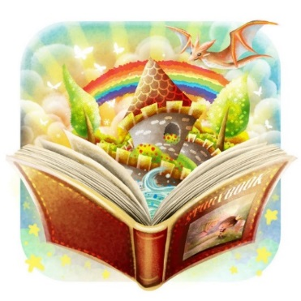
Spring 2 ~ ‘Once Upon a Time’
Focus areas of Development and Learning for this topic;
~ Communication & Language
~ Being Imaginative and Expressive
~ Literacy
This half-term, our theme is ‘Once Upon a Time’. We will read many different stories and sort books into different genres. We will talk about our favourite stories and celebrate World Book Day. We will have two main stories to focus on and look at in more detail; The Three Little Pigs and The Three Billy Goats Gruff. Nursery will act out and retell these stories, learn new vocabulary, place events in the right order and continue to develop their fine-motor skills, particularly using pencils. Reception will act out these stories, make story maps, write their own simple versions and write descriptions of characters and/or settings.
At the end of this half-term, we will learn about Easter and the traditions that go with it.

PE
Reception - We are going to develop our dance skills through moving and responding to music. We will create movements based on an overall theme (e.g. dinosaurs, animals) and build sequences with these, including partner work.
Nursery - We are going to develop our dance skills through moving and responding to music. We will copy and practise movements using Sticky Kids and other online resources. We will also play Musical Statues to allow us to practise moving rhythmically to music and to practise holding a balance.
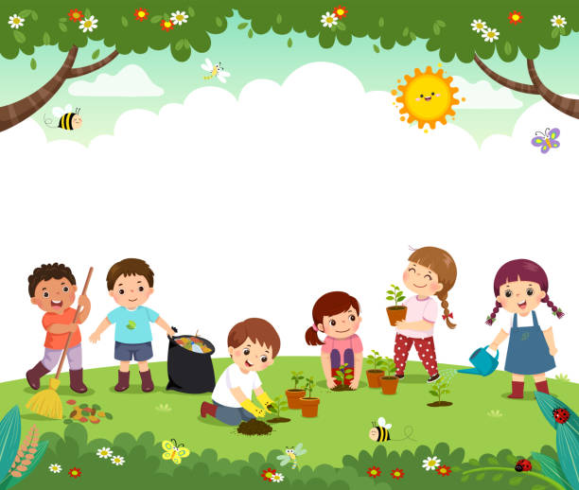
Summer 1 ~ ‘In the Garden’

Focus areas of Development and Learning for this topic;
~ The Natural World (Science)
~ Creating with Materials

The theme this half-term is ‘In the Garden’. Our focus books; Jasper’s Beanstalk, Oliver’s Vegetables and Oliver’s Fruit Salad will help us to learn about different things that grow, and we will have some practical experience of planting our own seeds and observing the changes that we see.
We will also spend time outdoors, to observe seasonal changes of spring, and to find out what different minibeasts live in our garden. We will look at butterflies in particular, as we learn about their life cycle through having our own caterpillar/butterfly net in the classroom!
We will explore paint by printing to make caterpillar and butterfly artwork and colour mixing to make shades of green. We will also make pastel drawings of different minibeasts.

PE
We will use different resources, such as beanbags and balls, to develop skills in throwing, catching, aiming and rolling, amongst others. We will also have the opportunity to play some parachute games.

Summer 2 ~ ‘On the Move’

Focus areas of Development and Learning for this topic;
~ People, Culture & Communities (Geography)
~ Personal, Social and Emotional Development

The theme this half-term is ‘On the Move’. We will discuss different kinds of transport and also learn about how to be a safe pedestrian. Our focus book, Emma Jane’s Aeroplane, will introduce us to some different cities around the world. We will also follow children’s interests to see where their experience of transport and travel takes us.
A big part of this half-term is about preparing the children for their transition into their next class. We reflect on our time in Nursery/Reception and talk about our favourite memories, how we have changed and what we have learnt.

PE
The children practise skills and prepare for Sports Day. This includes running, using floor ladders and hurdles, and balancing small equipment whilst moving!
After Sports Day, we revisit skills we have developed throughout the year through playing various games.

