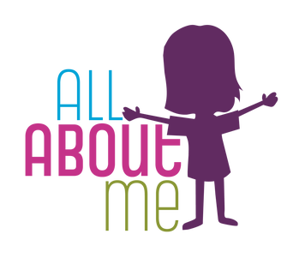
Autumn 1 ~ ‘All About Me’

Focus areas of Development and Learning for this topic;
~ Personal, Social and Emotional Development
~ Communication and Language
~ Physical Development

Our first theme is ‘All About Me’. This involves getting to know the children really well and allowing them opportunities to get to know each other through play interactions. We learn our class rules and systems. There is also a big focus on developing children’s independence and confidence in accessing resources and making relationships with their peers and staff.
We use mirrors to make our own paper plate faces.

PE
The children will start PE after the first few weeks when they are more settled. The initial focus is on listening to instructions and exploring different ways of moving.
Children will spend lots of time in our outdoor area and have opportunities to run, skip, jump and access small bikes and scooters. They learn how to negotiate the space around them safely.

Autumn 2 - ‘Special Days’

Focus areas of Development and Learning for this topic;
~ Past and Present
~ People, Culture & Communities
~ Expressive Arts and Design

The theme this half-term is ‘Special Days’. We learn about celebrations and traditions that the children may be involved in, which could include; birthdays, Halloween, Bonfire Night, Remembrance Day, Hanukkah and Christmas. The children begin to understand the importance of respecting other people’s differences and beliefs.
We create many different pieces of artwork through making fireworks collages, crafts and Christmas cards.

PE
Reception – PE lessons will continue to focus on developing general movement skills and spatial awareness. Children will explore moving in a variety of ways including hopping, jumping, running, crawling and slithering.

Nursery – Children will develop their early movement and dance skills through actions linked to ‘special days’.

Spring 1 ~ ‘Winter’

Focus area of Learning and Development for this topic;
~ The Natural World (Science)
~ People, Culture & Communities (Geography)

Our new topic in Early Years is ‘Winter’. We will look at seasonal changes that happen in Winter and hopefully observe signs of frost, ice, and maybe even snow in our outdoor area. We will explore the processes of freezing and melting using ice. We will then learn about the polar regions of our world, including; the landscape, animals and the lives of any people that live there.
We will also learn about Chinese New Year and how it is celebrated.

PE
Reception - We are going to begin simple gymnastics this half-term. This will focus on balancing, travelling in different ways, rolling and jumping safely. We will begin to use larger pieces of apparatus including mats, benches and our climbing wall/frame.

Nursery – We will develop our early gymnastics skills using positional language.

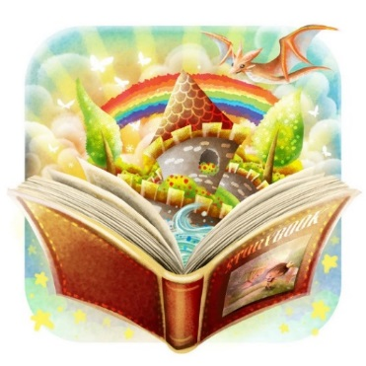
Spring 2 ~ ‘Once Upon a Time’
Focus areas of Development and Learning for this topic;
~ Communication & Language
~ Being Imaginative and Expressive
~ Literacy

This half-term, our theme is ‘Once Upon a Time’. We will read many different stories and sort books into different genres. We will talk about our favourite stories and celebrate World Book Day. We will have two main stories to focus on and look at in more detail; The Gingerbread Man and Hansel and Gretel. Nursery will act out and retell these stories, learn new vocabulary, place events in the right order and continue to develop their fine-motor skills, particularly using pencils. Reception will act out these stories, make story maps, write their own simple versions and write descriptions of characters and settings.
At the end of this half-term, we will learn about Easter and the traditions that go with it.

PE
Reception - We are going to develop our dance skills through moving and responding to music. We will create movements based on an overall theme (e.g. dinosaurs, animals) and build sequences with these, including partner work.
Nursery - We are going to develop our dance skills through moving and responding to music. We will copy and practise movements using Sticky Kids and other online resources. We will also play Musical Statues to allow us to practise moving rhythmically to music and to practise holding a balance.
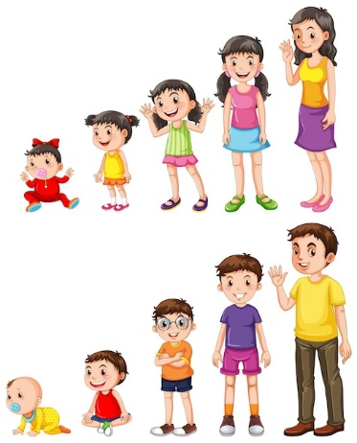
Summer 1 ~ ‘Growing Up’

Focus areas of Development and Learning for this topic;
~ Past and Present (History)
~ People, Culture & Communities (Geography)
~ The Natural World (Science)

The theme this half-term is ‘Growing Up’. We learn about human growth and development and reflect on how we have changed since we were babies. We talk about the different generations in our family and compare this to the different generations in the Royal Family. This leads us into learning about London and famous landmarks and traditions associated with the Royal Family.
We also learn about the life cycle of a frog through our focus book ‘Tad’.

PE
We will use different resources, such as beanbags and balls, to develop skills in throwing, catching, aiming and rolling, amongst others. We will also have the opportunity to play some parachute games.

Summer 2 ~ ‘The Seaside’

Focus areas of Development and Learning for this topic;
~ The Natural World (Science)
~ People, Culture & Communities (Geography)
~ Personal, Social and Emotional Development

The theme this half-term is ‘The Seaside’. We start by learning about seasonal changes outside. We then focus on the seaside as a popular destination to visit during summer time. We use stories to help us learn related vocabulary, including learning about life under the sea.
A big part of this half-term is about preparing the children for their transition into their next class. We reflect on our time in Nursery/Reception and talk about our favourite memories, how we have changed and what we have learnt.

PE
The children practise skills and prepare for Sports Day. This includes running, using floor ladders and hurdles, and balancing small equipment whilst moving!
After Sports Day, we revisit skills we have developed throughout the year through playing various games.

