After School Clubs: Spring / Summer 2024

Article 29: Article 31: Education must develop every child’s Every child has the right to relax, play personality, talents and abilities to the full and take part in a wide range of cultural
and artistic activities

Dear Parents / Carers,

Please find information below showing some of the after school clubs that will be offered during the Spring / Summer Term 2024. Further details / letters will be sent out for individual clubs when they are due to take place.

Please contact Mrs. Dadswell or Mrs. Lavelle if you have any questions or suggestions for further after school clubs.

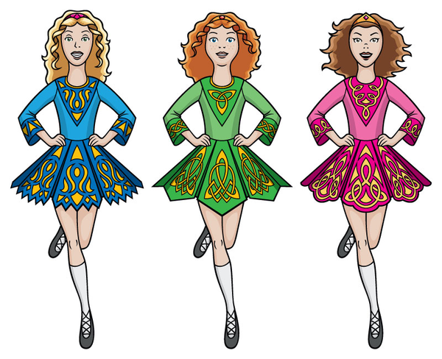

Tag Rugby: Year 5 Netball: Year 4 & 5 Athletics: Year 3-6
July March – May May / June
(Mrs Dadswell) (Mrs Dadswell) (Mrs Dadswell)

Cookery: Year 4 Irish Dancing: Y1 – Y6 Cricket: Year 5 & 6
March All Year March/April
(Mrs Wise) (Mr Storrar)

Fit and Fun: Year 1 Football: Year 3 & 4 Multiskills: Reception
March April / May June/July
(Coach) (Coach) (Coach)

French: Year 2 Wellbeing & Fun Games: Y1 & 2
June/July April/May
(Mrs Exley/Mrs Baum) (Mrs Dadswell)

